**AWS DevOps Capstone Project – Multi-Region Employee Manager Application**

**Author: Karumanchi Sai Yaswanth**

**Project Overview:**

This project demonstrates the **end-to-end deployment, monitoring, and scaling** of a containerized web application hosted on **Amazon EKS**, using **CI/CD pipelines** and **Infrastructure as Code (IaC)** tools. The architecture is designed for **high availability**, **resiliency**, and **observability** by deploying the stack across **two AWS regions**.

GIT REPO : <https://github.com/aH0-STS/AWS_CAPSTONE_PROJECT.git>

**Architecture Summary:**

**Application Stack**

* **Frontend:** Angular (deployed as container)
* **Backend:** Spring Boot (Java-based microservice)
* **Database:** Amazon RDS for MySQL

**Infrastructure & Deployment**

* **IaC Tools Used:**
  + **Terraform**: To provision VPC, Subnets, NAT Gateway, EKS Cluster, IAM Roles
  + **CloudFormation (CFT)**: For deploying RDS, Security Groups, NAT, and other networking components
* **Managed with:** AWS CodePipeline for CI/CD automation
* **Hosted on:** Amazon Elastic Kubernetes Service (EKS)

**CI/CD Integration**

* **Source Control:** GitHub
* **Build and Deploy Pipeline:** AWS CodePipeline
* **Code Quality:** SonarQube
* **Security Scanning:** Trivy
* **Deployment Automation:** ArgoCD for GitOps-based delivery

**Monitoring & Alerting**

* **Region 1:** Amazon CloudWatch (logs, metrics, alarms)
* **Region 2:** Prometheus + Grafana (custom metrics and dashboards)
* **Failure Alerts:** AWS EventBridge triggers Lambda to send email notifications via SNS

**Domain & Routing**

* **Domain Management:** Amazon Route 53 with **failover routing** policy
* **Ingress Controller:** Application Load Balancer (ALB) with **path-based routing** for frontend/backend

**Security & Permissions**

* **IAM Roles:** Custom roles with least privilege for EKS, EC2, and CodePipeline
* **RDS Protection:** Deployed in private subnets with security group restrictions
* **Sensitive Data:** Managed securely in Terraform (sensitive variables and outputs)

## Networking Layer

| **Resource** | **Description** |
| --- | --- |
| **VPC (Virtual Private Cloud)** | Custom VPC created for the application in each region with a /16 CIDR block (e.g., 10.0.0.0/16), providing private IP addressing for all AWS resources. |
| **Subnets (6 total)** | Split across **2 Availability Zones** for high availability: - **2 Public Subnets** (1 per AZ) for ALB and NAT Gateways - **4 Private Subnets** (2 per AZ) for EKS worker nodes and RDS databases |
| **Internet Gateway (IGW)** | Attached to the VPC to allow internet access from the public subnets (e.g., for ALB). |
| **NAT Gateways (2)** | Placed in each AZ’s public subnet, allowing EKS worker nodes and private RDS instances to securely reach the internet (for patching, pulling container images, etc.). |
| **Route Tables** | Custom route tables for public and private subnets: - Public subnet route table forwards traffic to the IGW. - Private subnet route tables forward outbound traffic through NAT gateways. |

## Compute Layer: Amazon EKS

| **Resource** | **Description** |
| --- | --- |
| **Amazon EKS Cluster** | Fully managed Kubernetes control plane (1 per region) that orchestrates pods and deployments for the Spring Boot application. |
| **EKS Node Group (Managed)** | Auto-scaled group of EC2 instances (typically t3.medium or m5.large) managed by EKS for compute workloads. It spans multiple subnets for HA. |
| **Security Groups for EKS** | Controls inbound/outbound traffic: - Allow only ALB-to-node communication (e.g., ports 80/443) - Nodes can access RDS (port 3306) - EKS worker nodes have open internal cluster communication within VPC |

**Phase 1: EKS Deployment and CI/CD Setup MANAULLY IN ONE REGION**

1. I cloned a repo from github which works the application perfectly it has front end and backend separately

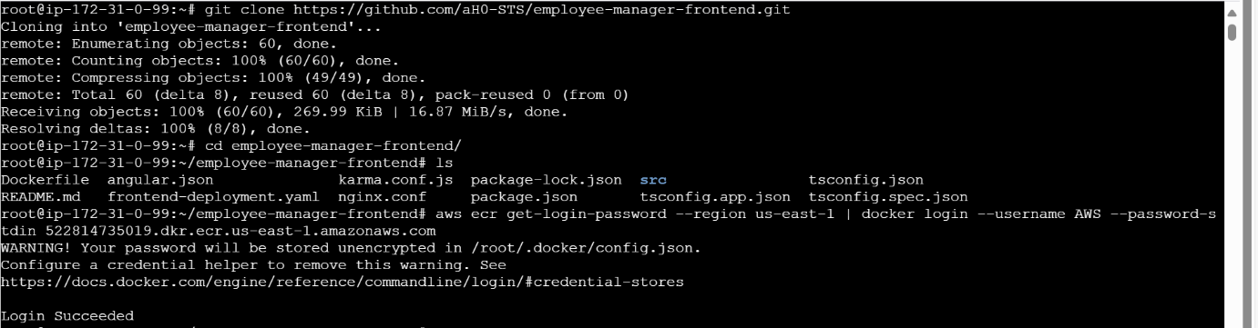

1. Created Dockerfiles for both frontend (Angular/React) and backend (Spring Boot).

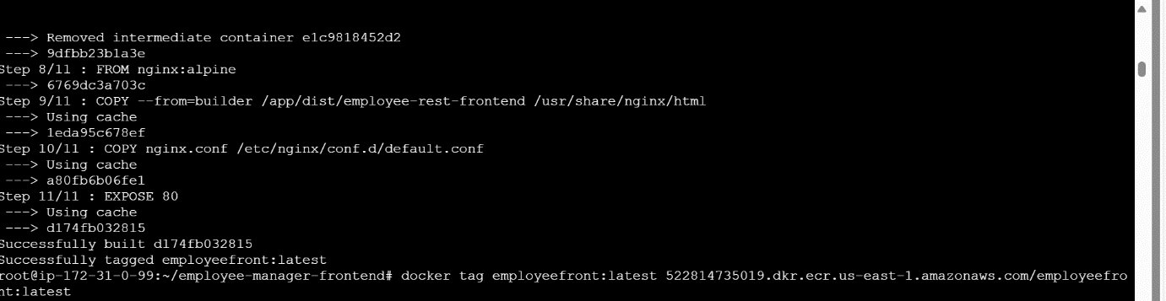

1. Built Docker images and pushed them to **Amazon ECR** repository for frontend

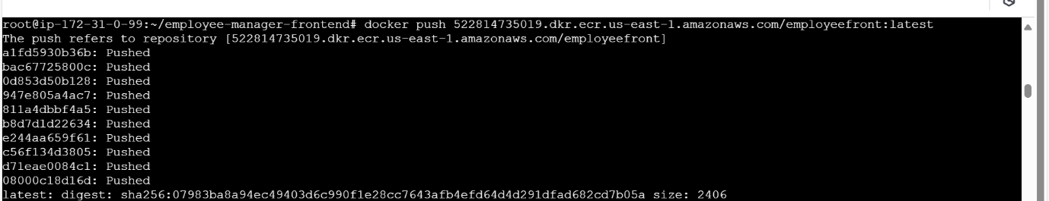

1. I changed the ecr image in my repo
2. Github repo : <https://github.com/aH0-STS/employee-front.git>
3. I created pipeline for front end : It contains SOURCE , BUILD , DEPLOY STAGE

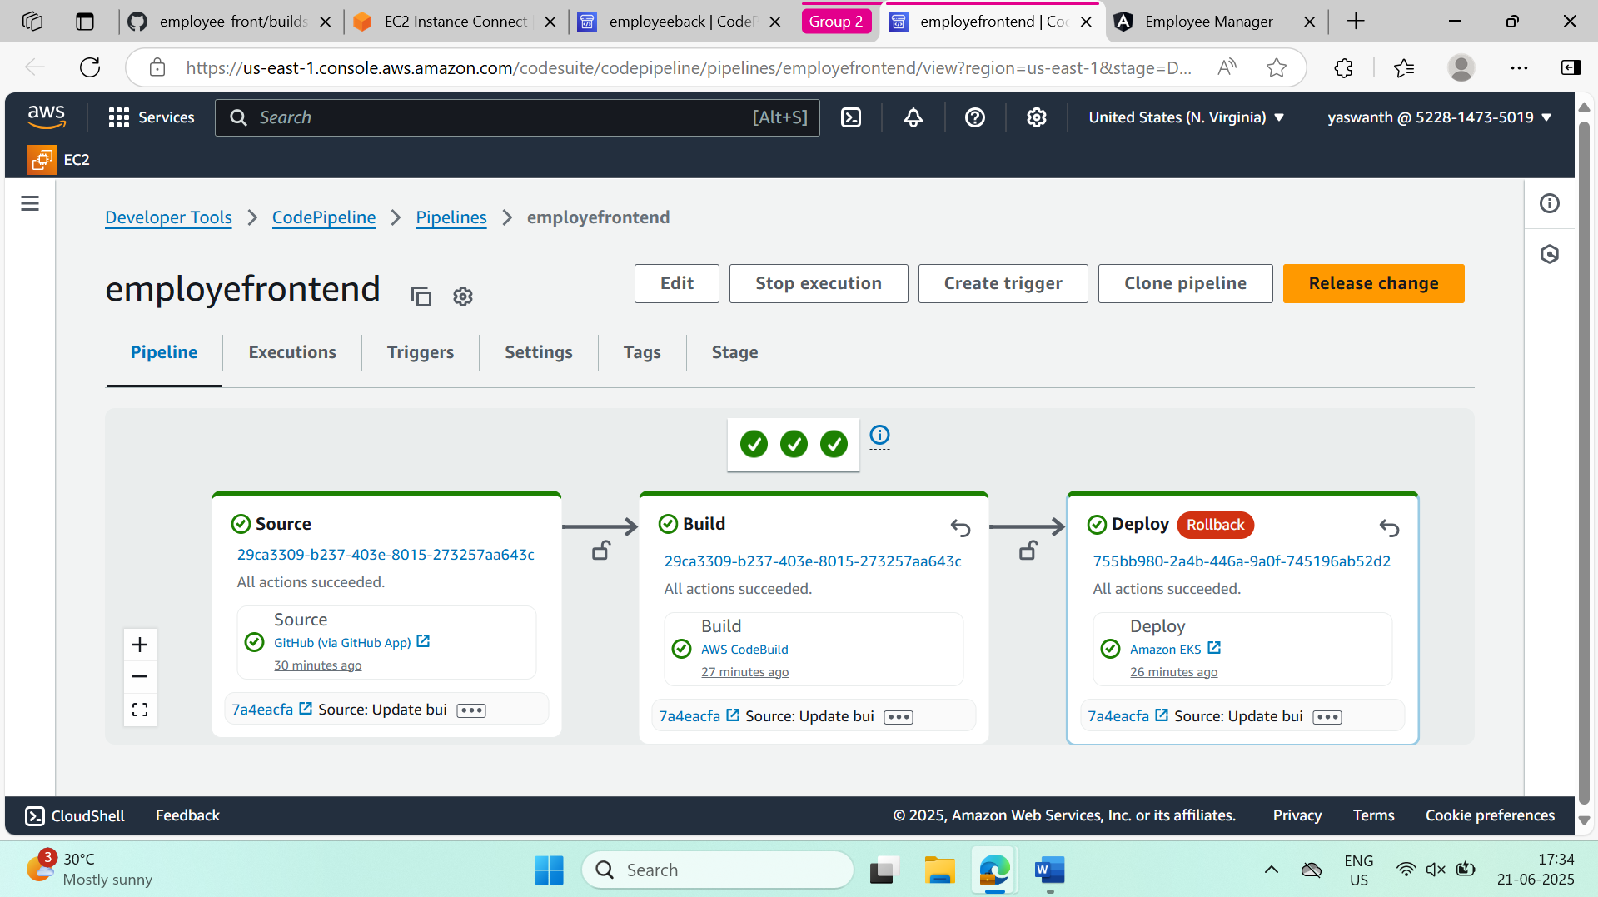

1. Check the pods are running properly or not

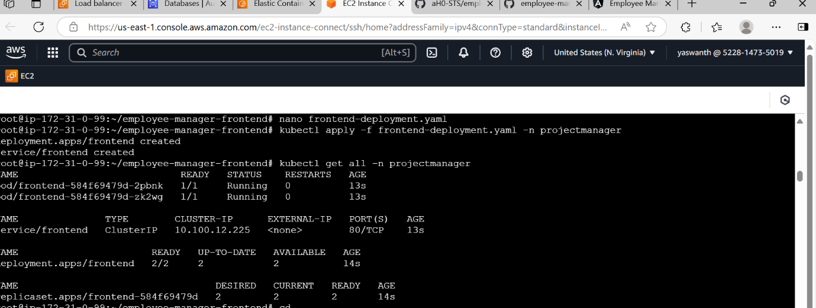

1. Same process is done for the backend pushing the image to ecr and changing the image In the code
2. Github repo : <https://github.com/aH0-STS/employee-back.git>

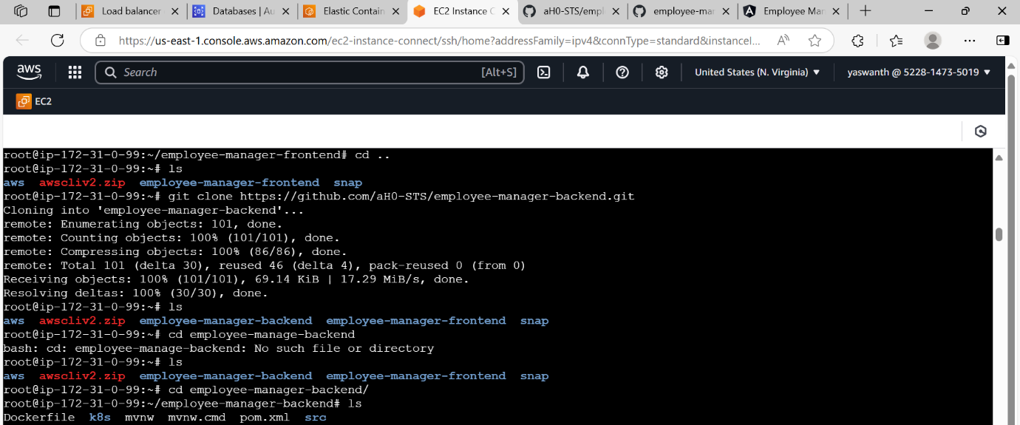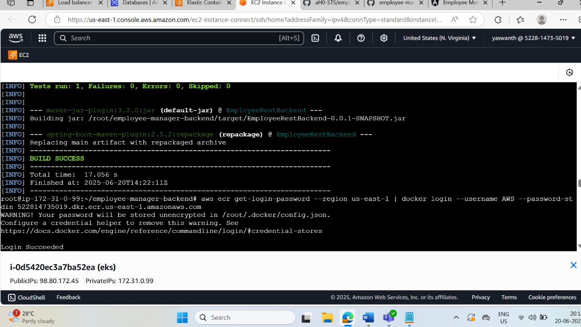

10 . pushing the image to ECR and using the image In code

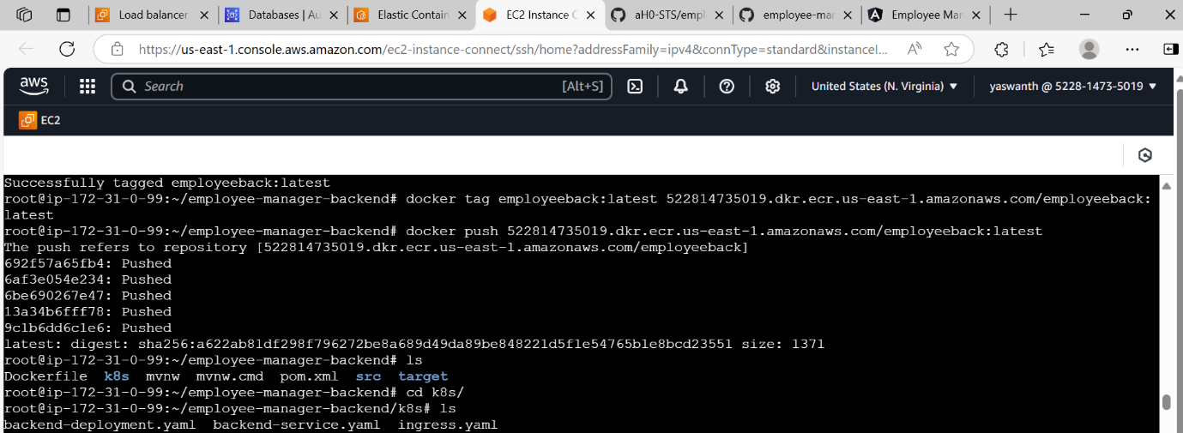

**Backend Pipeline**

* Created a buildspec.yml for backend.
* Configured CodePipeline stages:
  1. **Source**: GitHub Repository (Spring Boot Code)
  2. **Build**: CodeBuild compiles Java code, runs tests, builds Docker image, and pushes to ECR.

11 . build the pipeline for backend contains stages of SOURCE , BUILD , DEPLOY

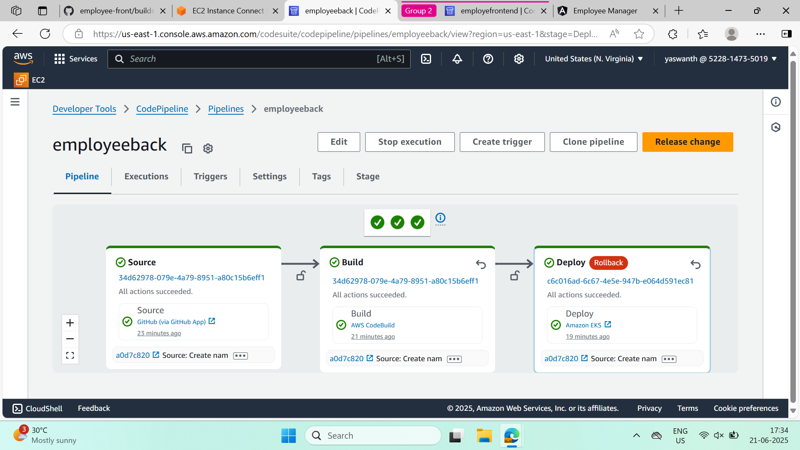

12. checking the all pods are running properly or not through commands given below

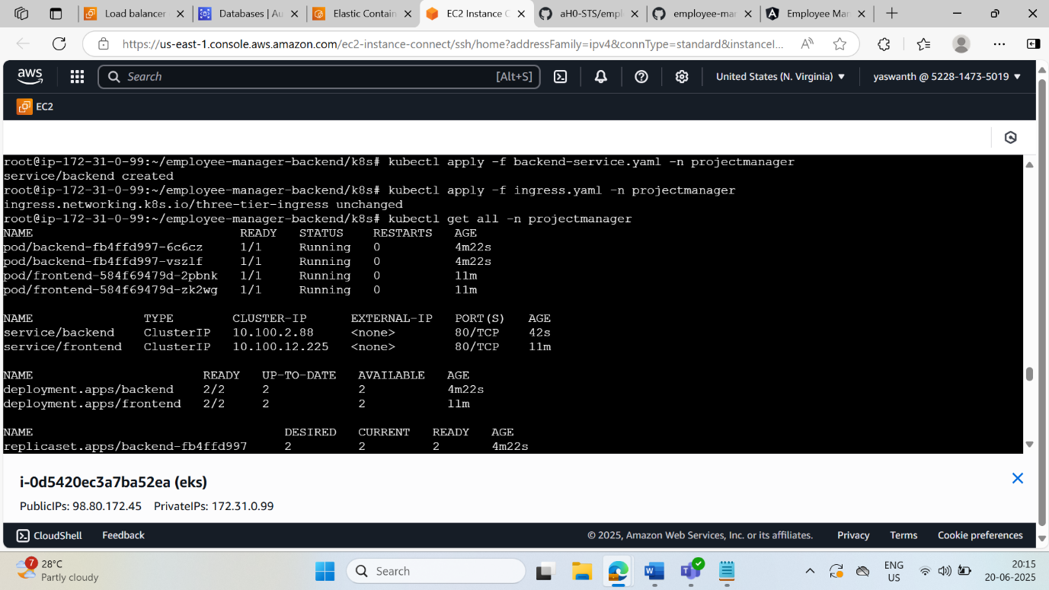

13. Now we can access the application through ingress-controller load balancer

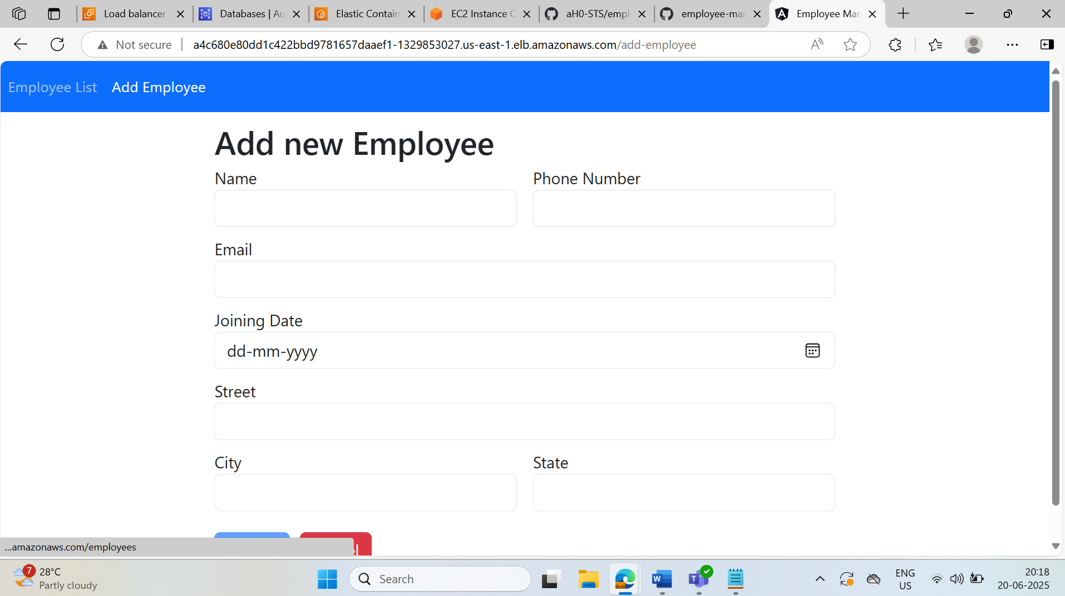

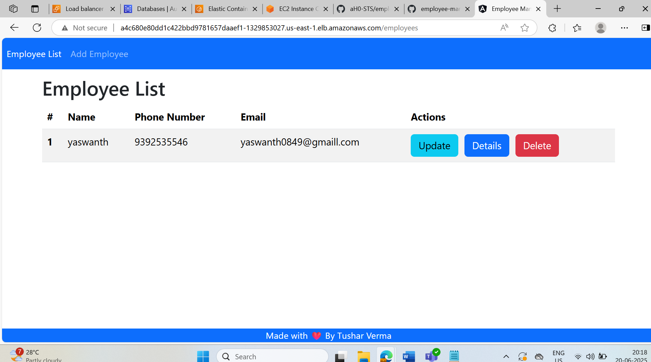

14 . we can check the database by connecting RDS to ec2 instance

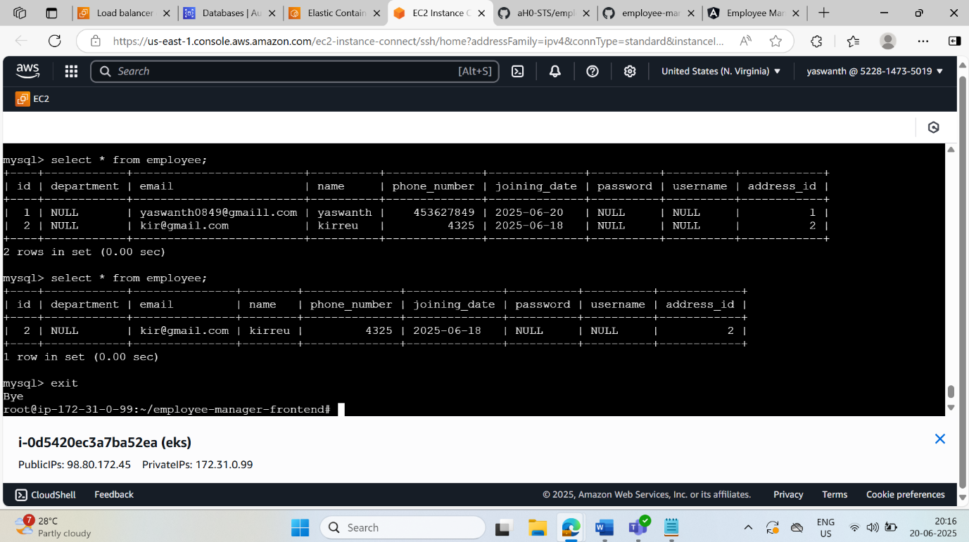

**PHASE 2: Fully Automated Deployment Using CloudFormation in us-west-1**

**Git repo for CFT:** [**https://github.com/aH0-STS/cloudlast.git**](https://github.com/aH0-STS/cloudlast.git)

**Objective:**

Replicate the Phase 1 infrastructure and application deployment using **AWS CloudFormation templates**, with **full automation via AWS CodePipeline**. All resources are provisioned and deployed automatically in the **us-west-1 region** without any manual steps.

**Infrastructure as Code with CloudFormation**

* Created modular **CloudFormation templates** for:
  + VPC, Subnets, Route Tables
  + Security Groups, IAM Roles, ECR Repositories
  + EKS Cluster and Node Groups
  + Application Load Balancer (ALB)
  + RDS (MySQL)
* Parameters were used for environment-specific values (e.g., region, CIDR blocks, DB passwords).

**This are the resources that are created from the template:**

* 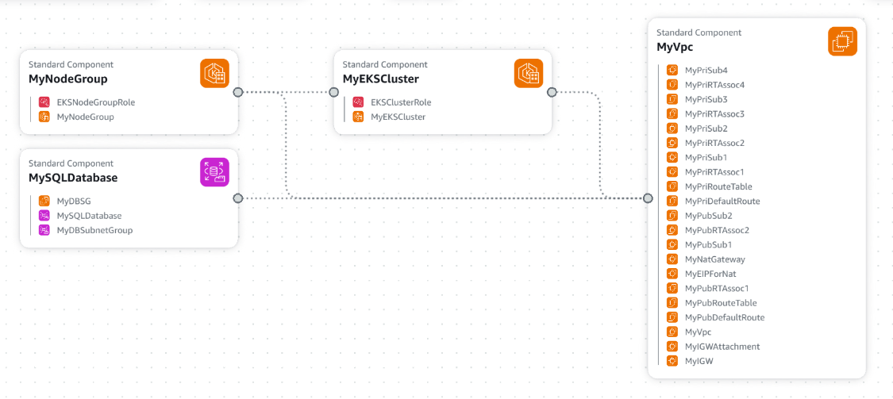

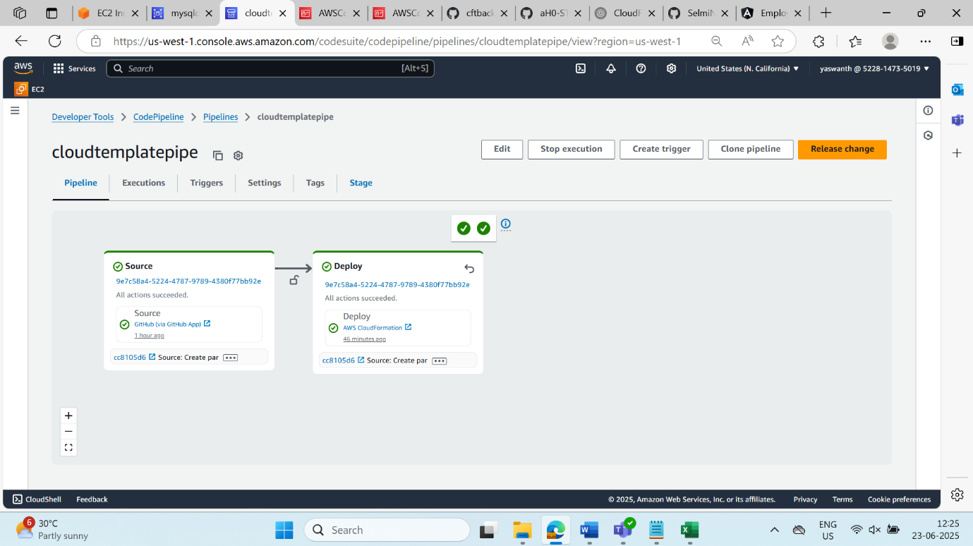

**ABOVE PIPELINE CREATES ALL THE RESOURCES THROUGH PIPELINE**

**CI/CD Pipeline for Infra + App**

* ✅ Built a **multi-stage CodePipeline** to orchestrate:
  1. **Source**: Pull CloudFormation templates and app code from GitHub.
  2. **Build Stage 1 (Infra)**: Uses CodeBuild to validate and deploy the CloudFormation stack for infrastructure creation.
  3. **Build Stage 2 (App)**:
     + Builds Docker images for frontend and backend.
     + Pushes images to respective **ECR** repos.
     + Deploys application using kubectl (from manifest files generated/updated during build).

AFTER creation of resources deploying the application through EKS CLUSTER

WHICH has separate pipeline for frontend and backend

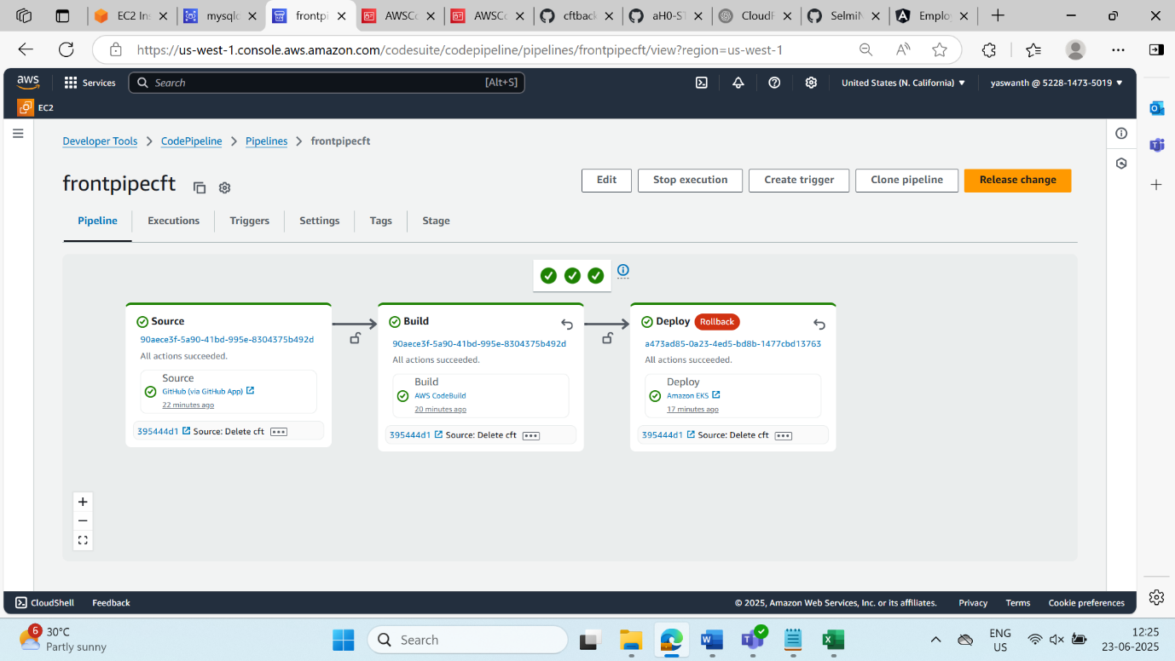

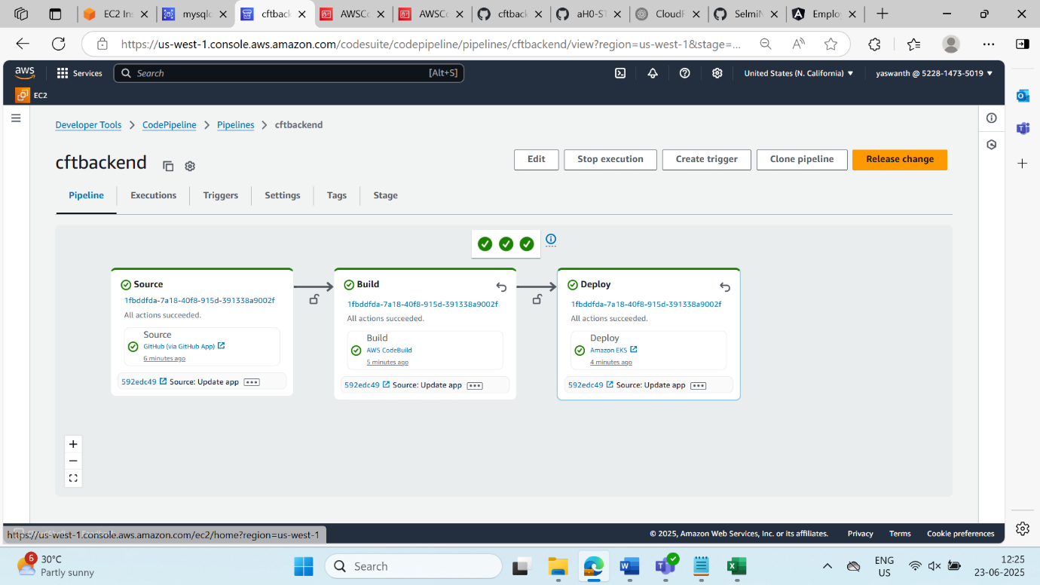

**SonarQube Integration with AWS CodePipeline**

Integrate **SonarQube** into the CodePipeline process for both **frontend and backend** to analyze code quality, detect bugs, vulnerabilities, and code smells **before deployment to production**.

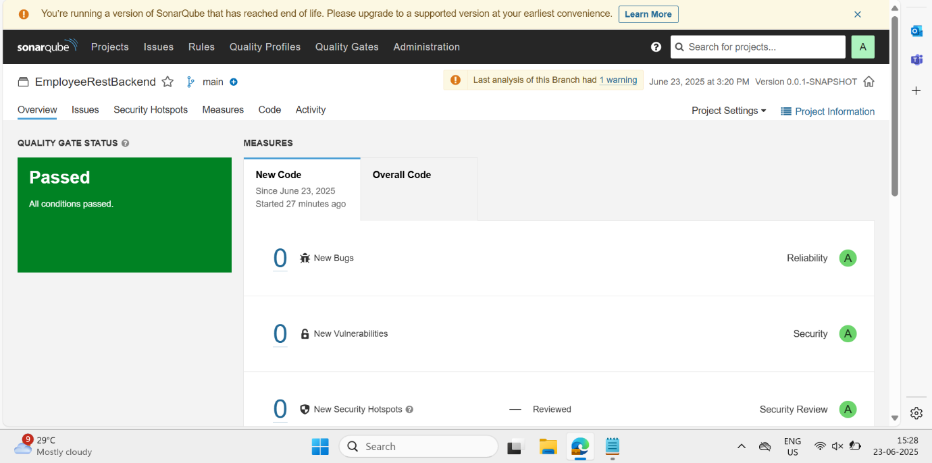

**Ingress Load Balancer Setup**

* Ingress Controller (NGINX or AWS ALB Ingress) was deployed post-EKS creation.
* CloudFormation included **Ingress configuration** or was deployed via kubectl through the pipeline.

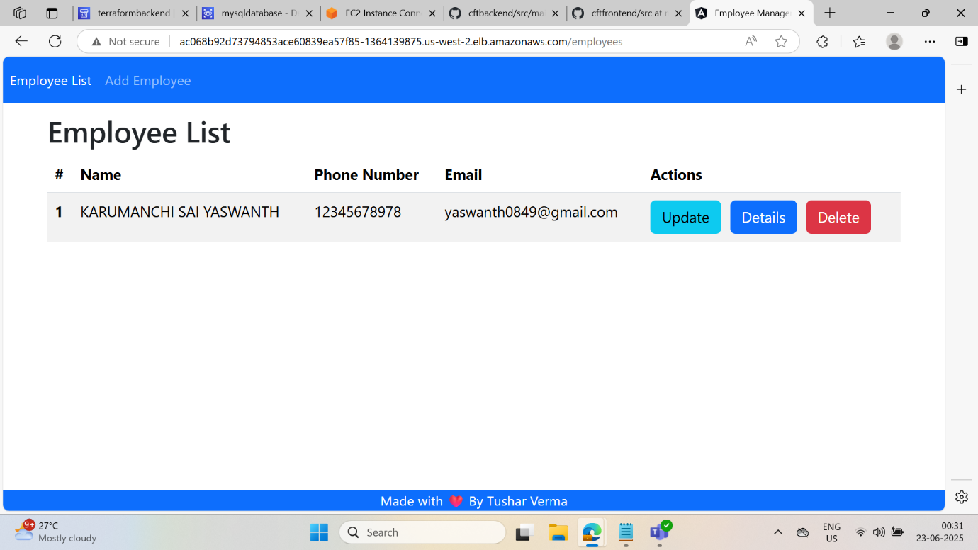

WE can check the application database by connecting through rds in ec2 instances

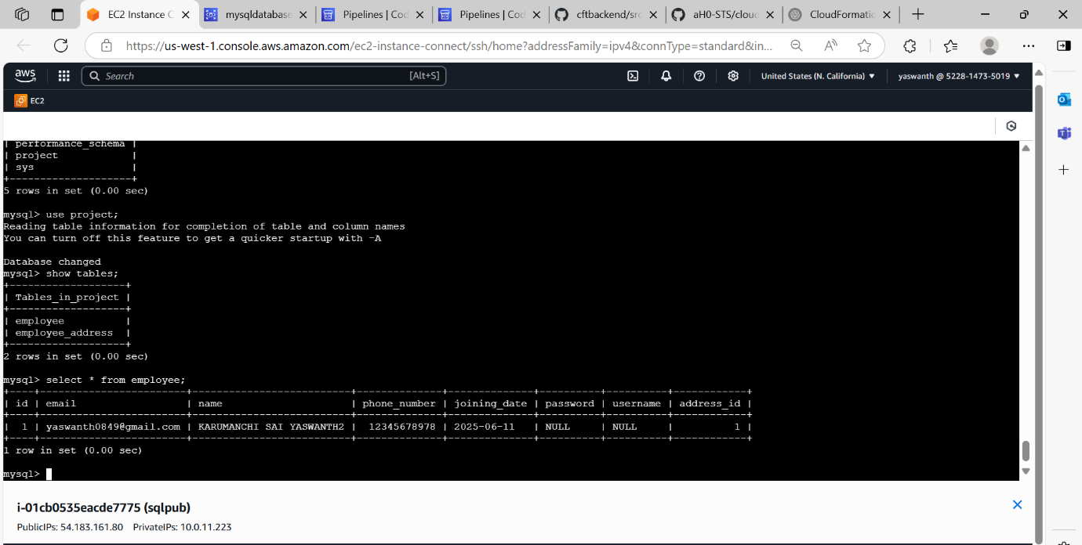

**Phase 3: Infrastructure & Deployment Automation Using Terraform in**

**us-west-2**

**Objective:**

Provision all necessary AWS infrastructure using Terraform in the us-west-2 region, and set up CI/CD pipelines for frontend and backend deployment. Access the application via a public endpoint exposed through an Ingress Load Balancer

TERRAFORM CODE DIVIDED INTO

**MAIN.TF , VARIABLE.TF , OUTPUTS.TF**

After use the commands to reflect and create resources :

**TERRAFORM INIT**

**TERRAFORM VALIDATE**

**TERRAFORM PLAN**

**TERRAFORM APPLY**

**I/CD Pipelines for Frontend & Backend**

* Configured two separate CodePipelines with independent triggers:
  + One for Frontend (Angular/React)
  + One for Backend (Spring Boot)
* Each pipeline includes:

**Source Stage**: Pulls from respective GitHub repositories

**Build Stage (CodeBuild):**

* + - Runs buildspec.yml
    - Builds Docker image
    - Pushes to Amazon ECR

**Deploy Stage:**

* + - Uses kubectl or ArgoCD to apply manifests in us-west-2 EKS cluster

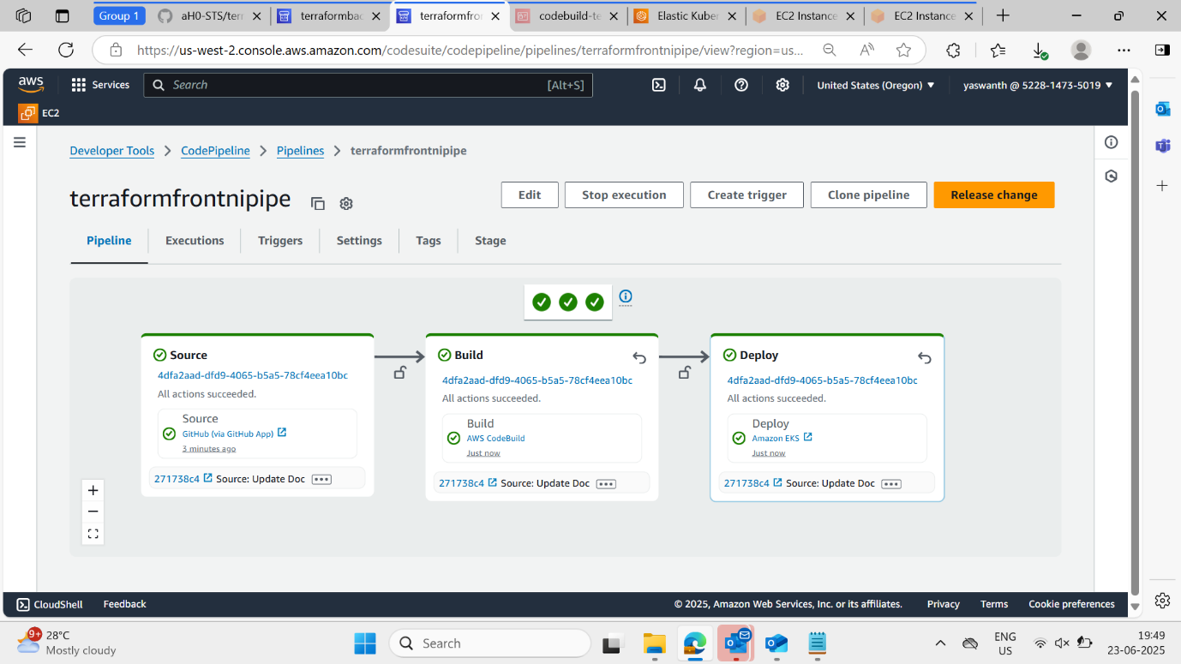

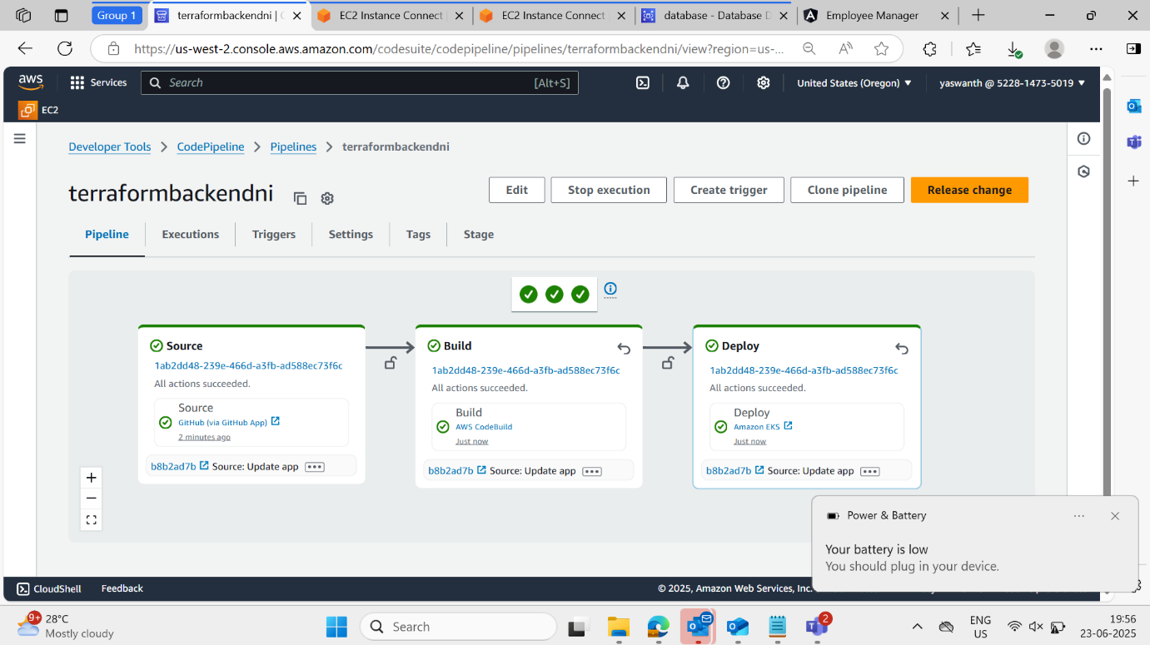

**Ingress Controller & ALB**

* ALB Ingress Controller deployed via Helm or Terraform post-EKS creation.
* Ingress manifest configured with path-based routing:
  + / → Frontend service
  + /api → Backend service
* Application is accessed via public DNS name of the ALB in us-west-2.

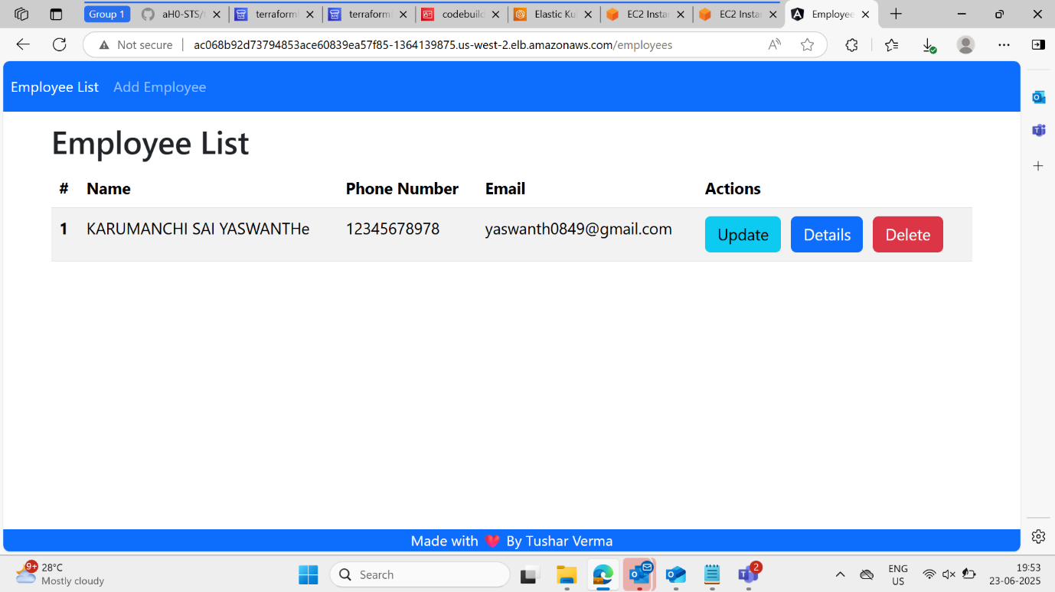

CHECKING THE DATABASE:

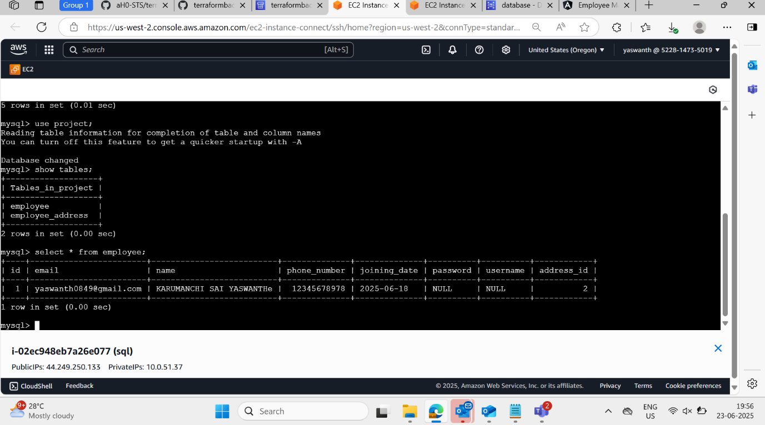

**Route53**

After deploying your infrastructure in two AWS regions (us-west-1 via CloudFormation and us-west-2 via Terraform) implementing Route 53 to manage global traffic routing between the two.

**Objective:**

Create a **Route 53 DNS failover setup** that intelligently routes user traffic to the application endpoints deployed in us-west-1 and us-west-2. This ensures **high availability** and **disaster recovery** using **active-passive failover** across regions.

1.Create or register a domain name my domain is

**yashust.com**

**yash.click**

2.health check for two regions

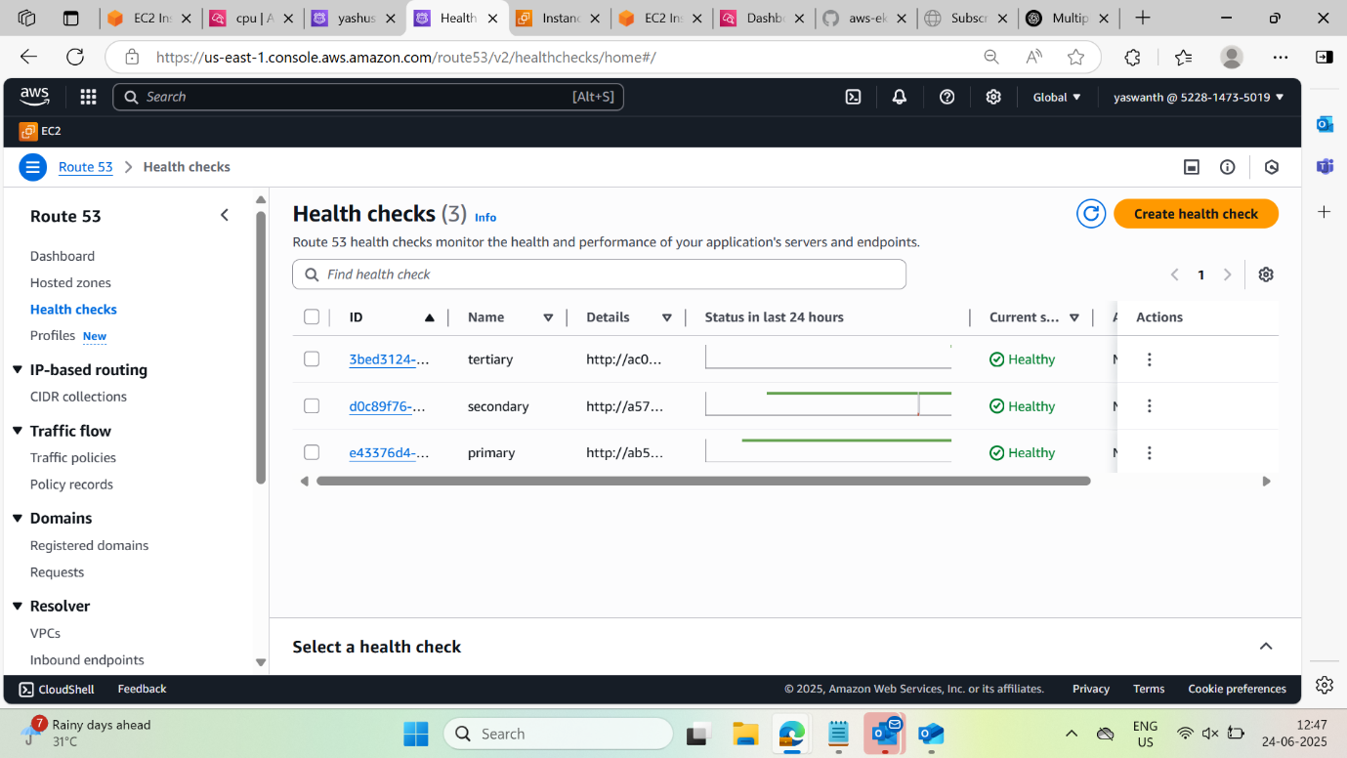

**3.Create DNS Records (Failover Routing)**

* Created **two A (or CNAME) records** with failover type:

**Primary Record**

**Secondary Record**

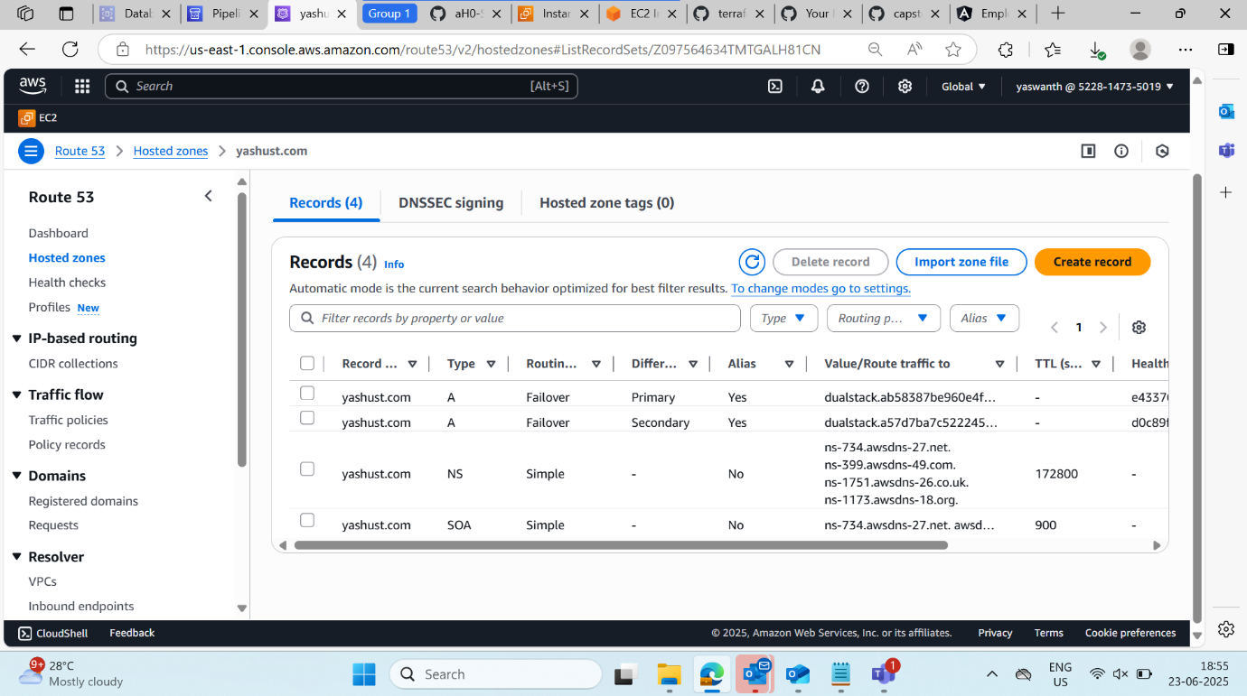

WE CAN ACCESS THE APPLICATION THROUGH DOMAIN NAME : **yashust.com**

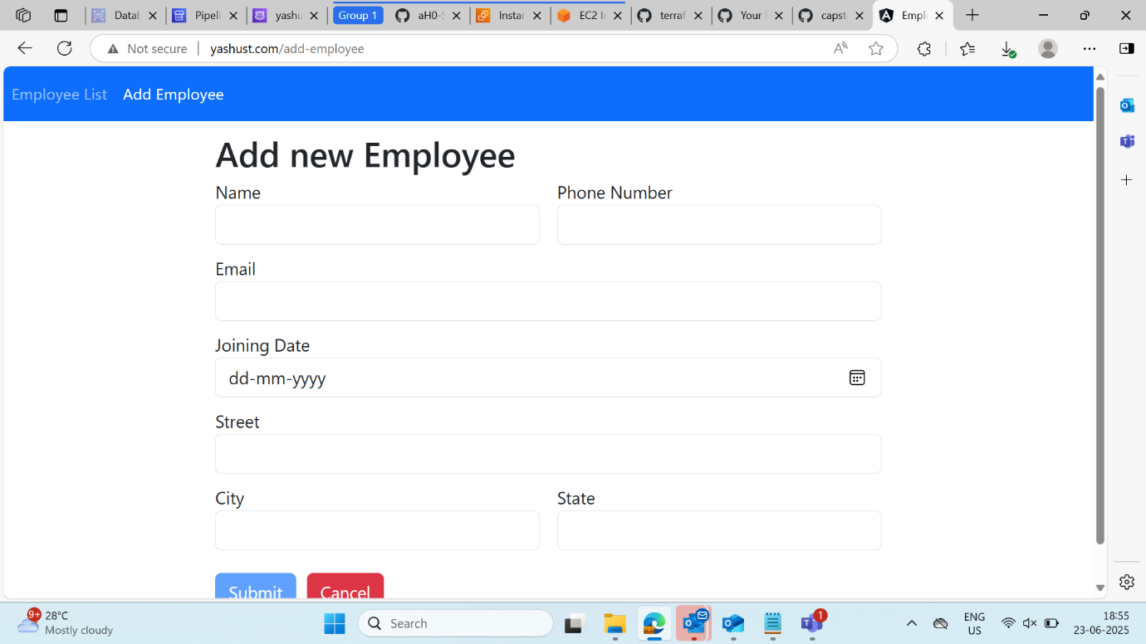

**CLOUDWATCH**

**CloudWatch Monitoring & Alerting with SNS Notification:**

**FOR MONITORING IN ONE REGION WE USE CLOUDWATCH:**

set up CloudWatch monitoring for EC2 or EKS worker nodes to track CPU utilization, and configure SNS-based alerting to notify via email when CPU usage exceeds 75%.

1.Configuring adding ekscluster to cloudwatch

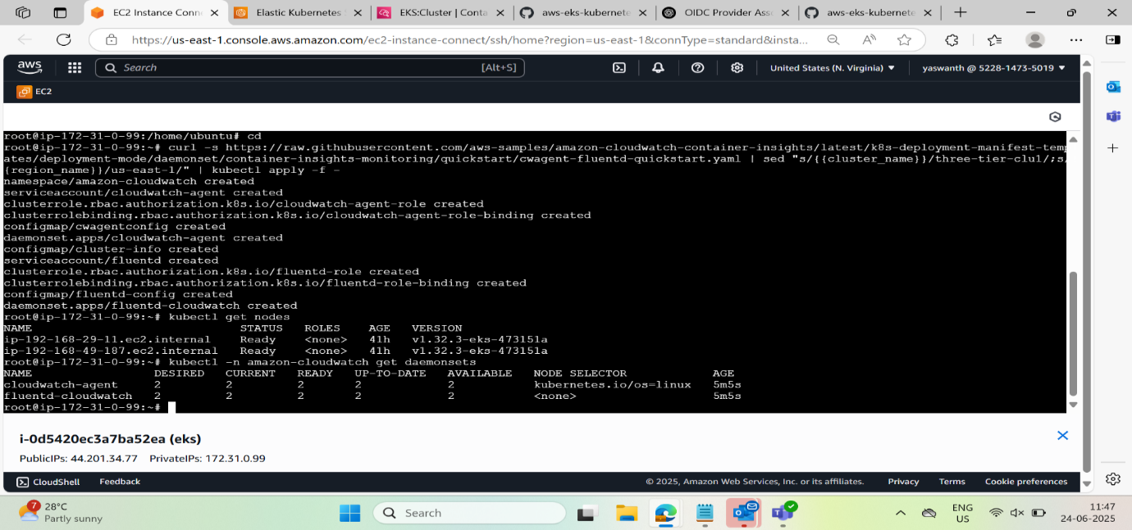

**2.DASHBOARD OF CLOUDWATCH**

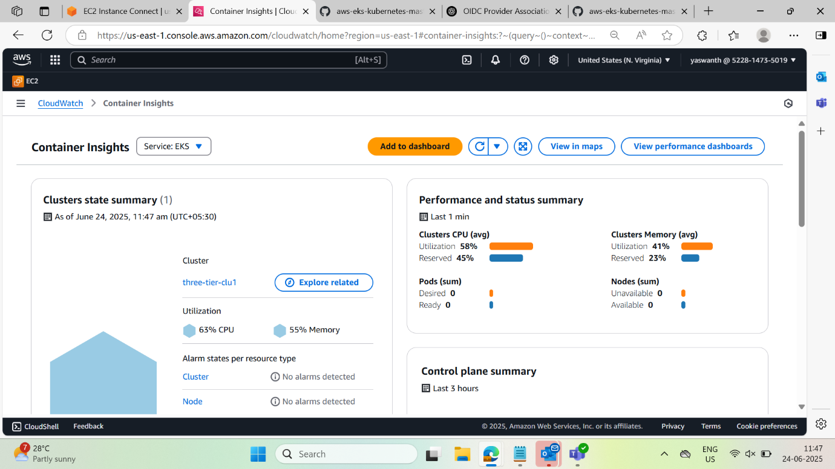

3.creation of Alaram if cpu ultilization is more than 75% through SNS

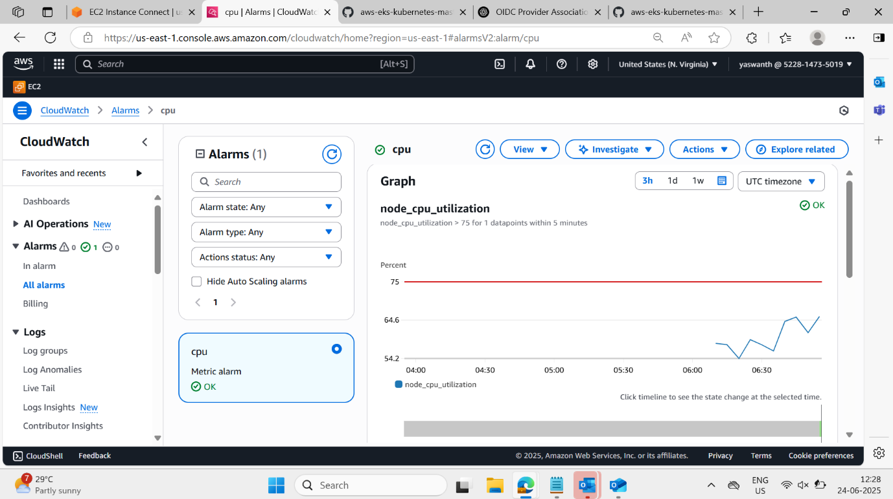

We can see the graph of the cpu utilization :

We will receive email once it reaches more than 75%

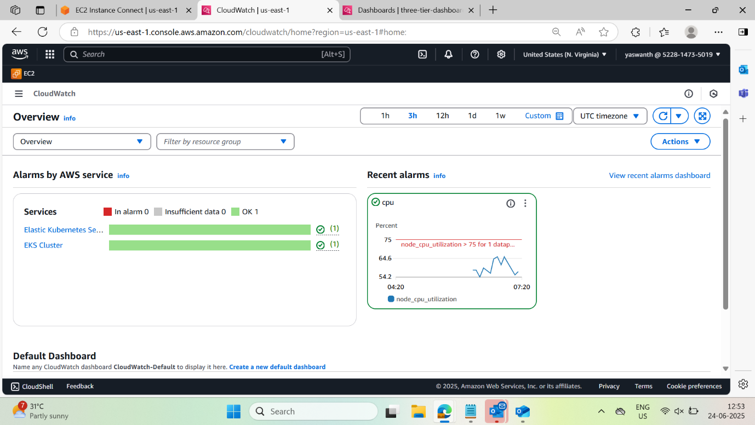

**Event bridge :**

**Event-Bridge Alerts on CodePipeline Failure using EventBridge, Lambda, and SNS**

**Step1: create a sns topic and subscribe**

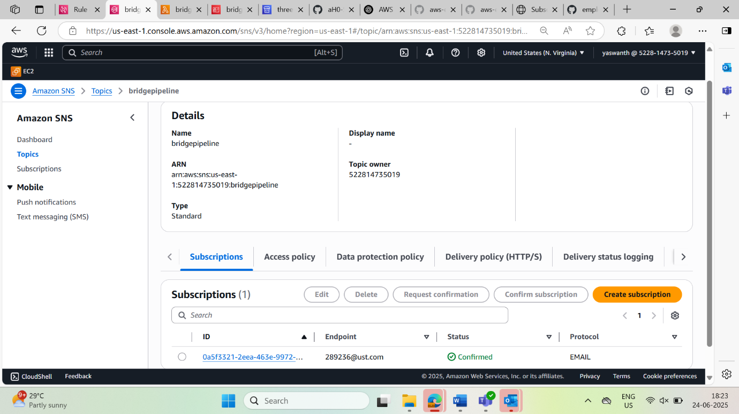

**Step2: create a lambda function code consists of codepipline fails it will trigger through sns**

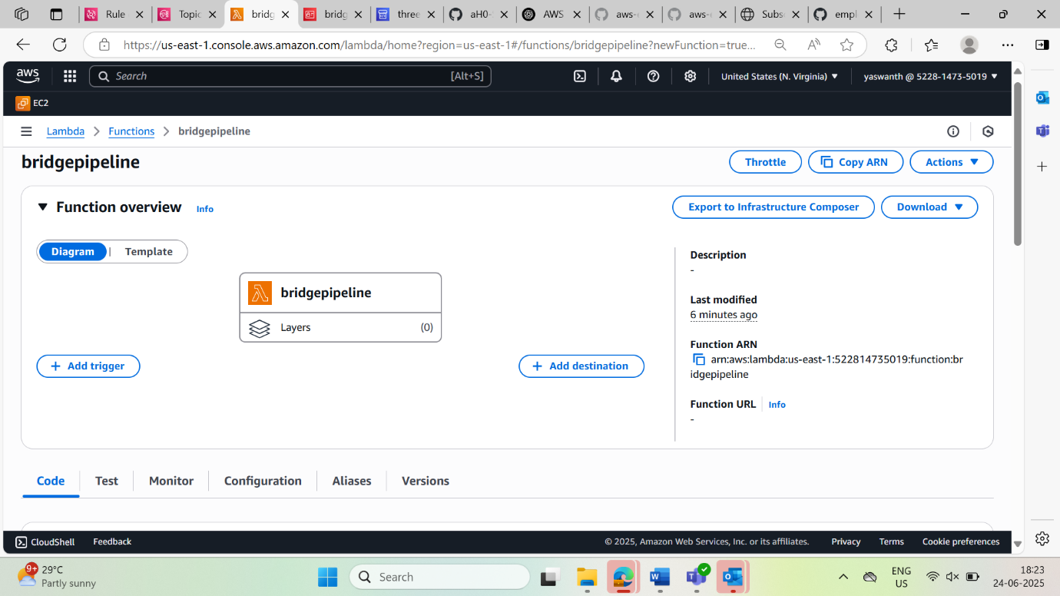

Code for pipeline failure:

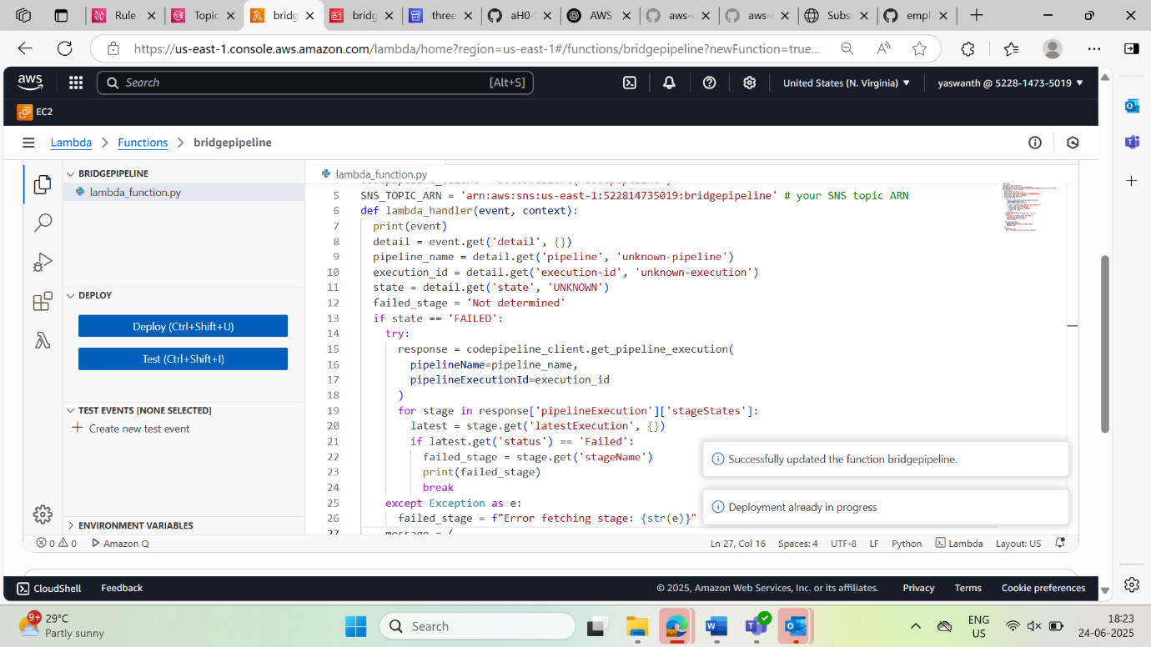

NOW U CAN SEE I failed a pipeline wantedly then I got the email

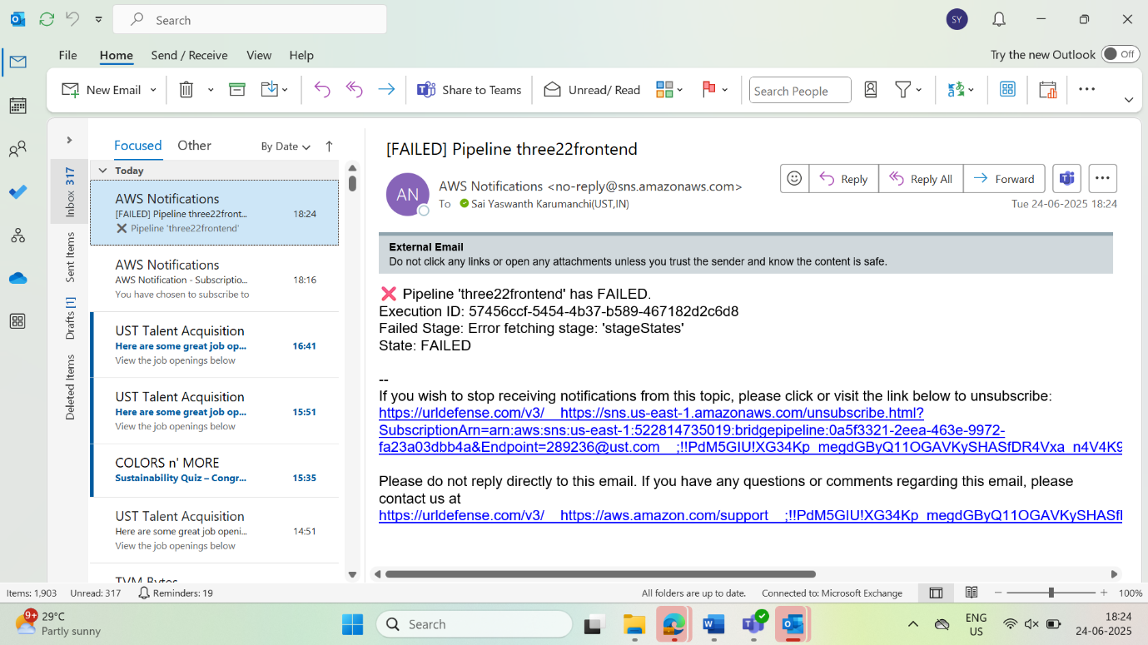

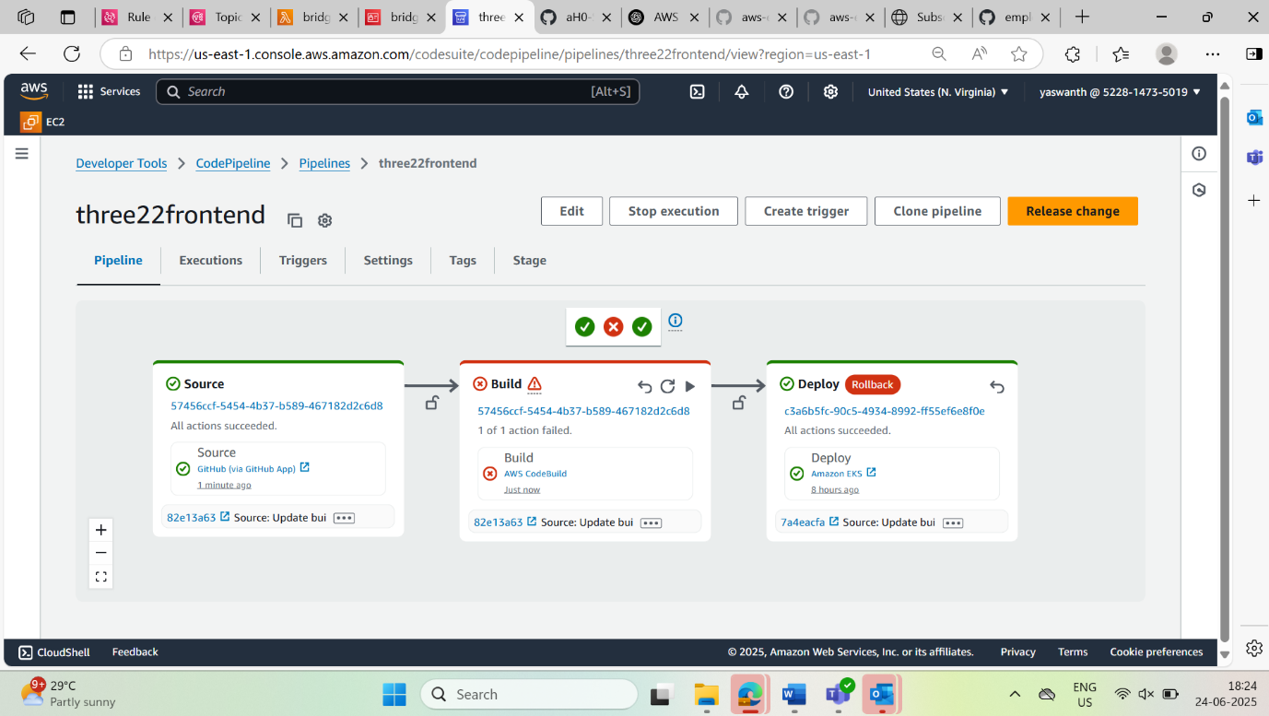

**ArgoCD – GitOps-based Continuous Deployment for EKS**

**Objective:**

Implement **ArgoCD** for declarative and automated application deployment in the EKS cluster using **GitOps principles**. All Kubernetes manifests are synced directly from the GitHub repository.

1.configuration of argocd through eks cluster in ec2 instance

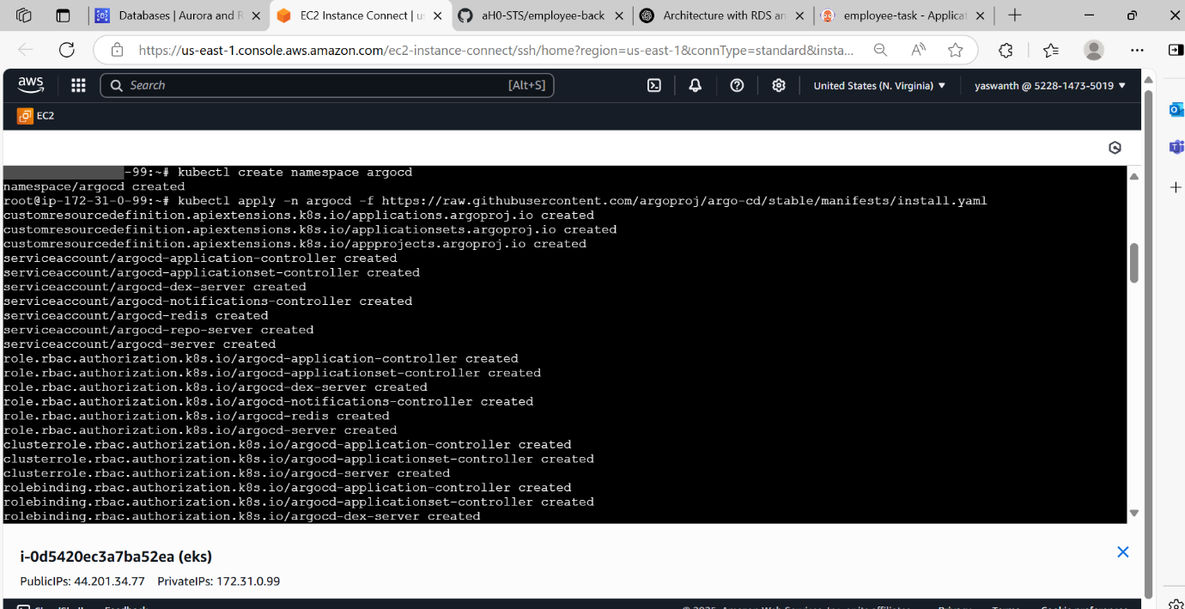

2.Access it through argoCD loadbalancer

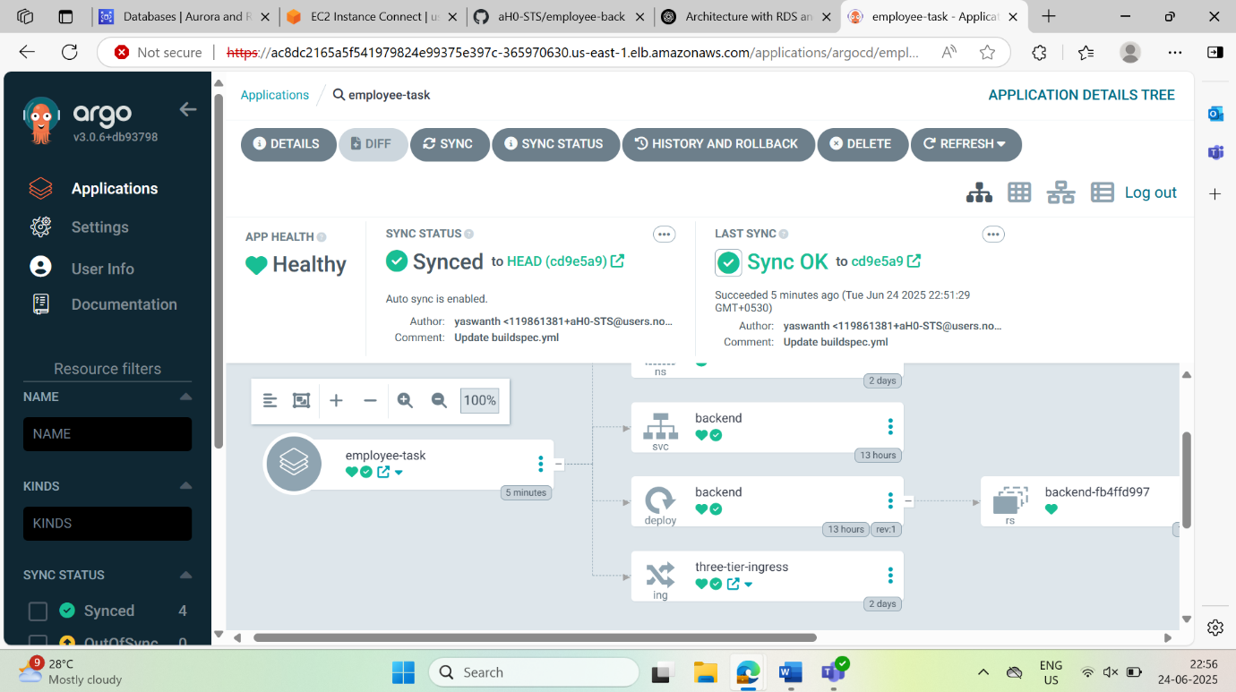

**Monitoring and Visualization with Prometheus & Grafana**

**IN SECOND REGION I USED PROMETHEUS AND GRAFANA FOR MONITORING**

To monitor the health and performance of the Kubernetes cluster and application components (frontend, backend, node metrics) using **Prometheus** and visualize real-time metrics via **Grafana dashboards**.

Prometheus is a **cloud-native monitoring system** that scrapes metrics from targets (pods, nodes, services) at specified intervals and stores them as time-series data.

Grafana is a **visualization tool** that connects to Prometheus and other data sources to display data through **interactive dashboards** and **alerts**.

1.Follow the documentation to install and configure Prometheus and Grafana

2.Access it through ip or loadbalancer

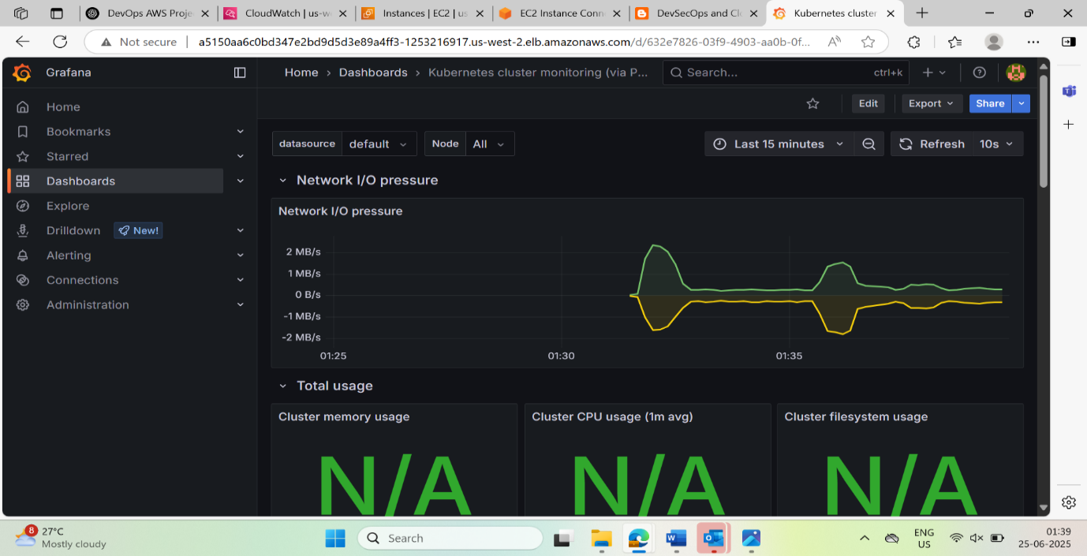

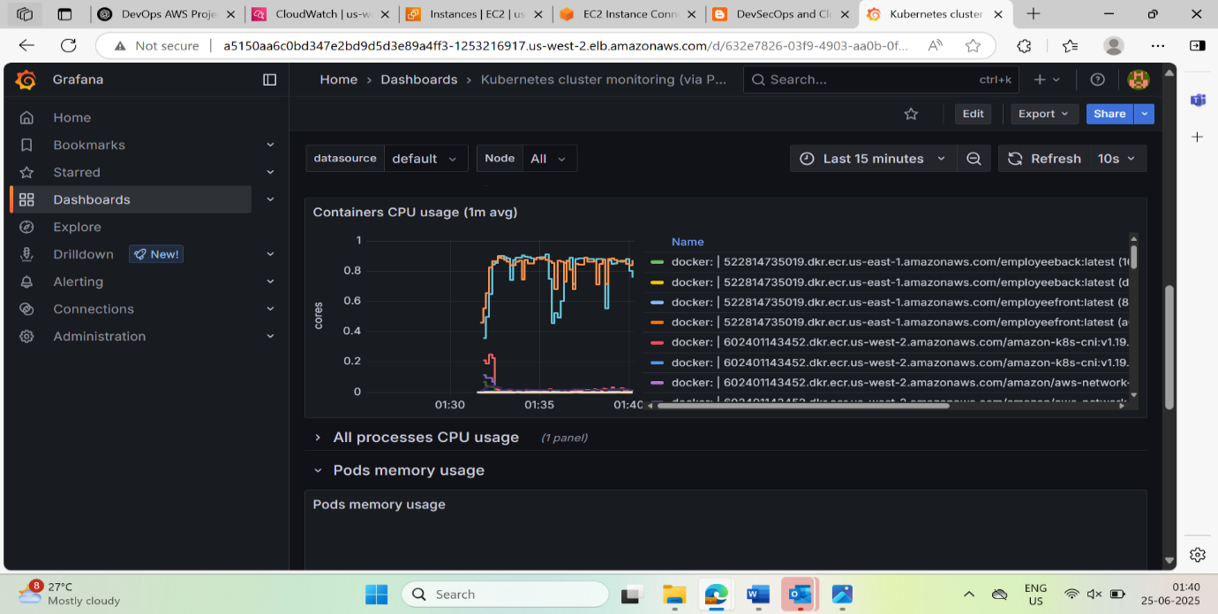

**AWS BACKUP PLAN:**

adding an AWS Backup Plan (often referred to as “backup strategy” or “resiliency plan”) is crucial for showcasing that your project is not only functional and scalable, but also disaster-resilient and data-protected.

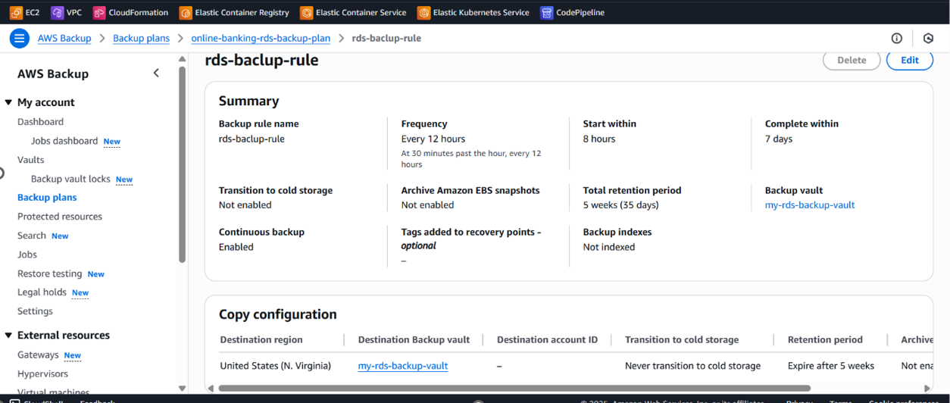

**Future Enhancements:**

1. Integrate AWS Secrets Manager

2. Blue/Green or Canary Deployments

3. Add Slack / Teams Notifications

**Conclusion:**

This project demonstrates a **complete DevOps lifecycle** implementation on AWS using modern, scalable, and secure cloud-native tools.

This project not only automates infrastructure and deployment but also ensures quality, scalability, observability, and high availability — reflecting real-world enterprise DevOps practices on AWS